2021 Report on the Health of the Norway Lakes
Prepared by Stephan Zeeman, Ph.D.
Water Quality Team: Paul Shook, Jim O’Brien, Jeanne Silverman
June 8, 2022
Contents
What matters 1
About the Report 1
Overview 2
Historical Perspective 3
Highlights of the 2020 sampling 5
Other parameters from the 2020 season 8
Individual Lake Analyses 10
Sand Pond: 10
Little Pennesseewassee (Hobbs Pond): 12
Lake Pennesseewassee: 13
North Pond: 14
Methods 15
Appendix A. 17

What matters
Before reading this report, it is important to realize why we measure and test our waters. It is to assess lake health and to understand the factors that affect that health. From a very simplistic perspective, we focus on what we can influence - preventing the growth of excess algae. High concentrations of algae do undesirable things like reducing water clarity and removing oxygen from lakes. The decreased light penetration can harm rooted vegetation on the bottom and decreases the aesthetic quality of the lakes. An overabundance can also lead to bad odors, foul smelling waters, and algal toxins which harm humans and animals. The biggest single item that promotes algae growth is phosphorus. While phosphorus occurs naturally in lakes, excess amounts can enter lakes via erosion, both from storm water runoff, and from shoreline erosion. Therefore, our primary measurements are water clarity and items related to phosphorus levels. We property owners can have a significant influence on phosphorus levels, which is why LAON devotes a lot of its efforts on erosion.

About the Report
The Lakes Association of Norway (LAON), with support from the Town of Norway and contributions from the membership, continues to monitor the health of the four Norway lakes:
- Lake Pennesseewassee (also called Norway Lake)
- Little Pennesseewassee Lake (also called Hobbs Pond)
- Sand Pond
- North Pond
The Courtesy Boat Inspection program for people bringing their boats into Lake Pennesseewassee continues, and has been successful at preventing invaders from getting into the lake. Due to covid-19 concerns, this year the Lake and Watershed Resource Management Associates (LWRMA) was not able to conduct an invasive aquatic species screening of our lakes. Fortunately, LAON’s volunteer Invasive Plant Patrols were able to survey most of all four lakes, and did not find any invasives.

The water quality team sampled the four lakes monthly between May and September, with additional water clarity measurements on some lakes. Water quality measures include Secchi depth for clarity, as well as temperature and dissolved oxygen profiles at 1-meter increments from surface to bottom. Total Phosphorus, Chlorophyll, pH, Alkalinity, Conductivity and Color were measured at surface and near-bottom. Samples for phosphorus and chlorophyll were analyzed at the Maine State Health and Environmental Testing Laboratory (HETL), as were one-time samples for Alkalinity and Calcium (the ratio is an indicator of sediment release of phosphorus). The other measures were analyzed by the team on-site. More details about our methods are included at the end of this document

Overview

Table 1 below shows the average values at the surface and bottom (except Secchi depth) of the lakes for primary water quality parameters measured for 2021 and also for 2020 to show the contrast. The year 2021 was an unusual year. Hobbs Pond (Little Pennesseewassee) had a cyanobacterial bloom in late summer. These organisms used to be called blue green algae and are photosynthetic. However, they may produce toxins that are harmful to people, dogs and livestock. The bloom was probably caused by increased nutrient levels. The high average P is

Table 1. Secchi depth, Total Phosphorus and Chlorophyll concentrations for 2020 compared to the historical average for the four lakes.
Lake | Average 2021 (2020) |  |  |  |  | Historical Avg *
 | Secchi | Avg P | P Surf | P Bot | Chl | Secchi | Avg P | P Surf | P Bot | Chl
Sand Pond | 7.32 (7.76) | 9.33 (9.87) | 4.26 (3.25) | 14.4 (16.5) | 2 (1) | 7.4 | 9 | 3 | 15 | 2.5
Little Pennesseewassee | 5.82 (6.93) | 22.4 (13.25) | 7.0 (6.25) | 37 (20.25) | 3 (2) | 5.3 | 14.5 | 10 | 19 | 4.5
Pennesseewassee | 5.73 (5.89) | 10.1 (10.2) | 6.0 (7) | 14.2 (13.4) | 3 (2) | 5.7 | 10.5 | 8 | 13 | 4.6
North Pond | 3.17 (3,14) | 24.5 (17.4) | 15,6 (17.4) | 33.4 (NA) | 6 (6) | 3 | 25.5 | 17 | 34 | 6.9
* Data through 2018 from http://www.gulfofmaine.org/kb/2.0/record.html?recordid=9678
Secchi - higher number is better |  |  |  | Improved
P - lower number is better |  |  |  | Worsened
 |  |  |  | Too close to call

mostly due to the bottom concentration being higher than average. The bloom probably occurred due to this water being stirred into the surface due to wind mixing. The other lakes also showed increased P concentrations but to a lesser degree. The high P concentrations are also reflected in the higher algal chlorophyll concentrations, and decreased light penetration as shown by the lower Secchi depths.

The good news is that 2021 saw lower phosphorus levels in the surface waters of Little Pennesseewassee, Pennesseewassee and North Pond relative to historic values.. However, there were higher concentrations of phosphorus in the bottom waters of Little Pennesseewassee and Pwennesseewassee compared to historical values. Perhaps concerning is that Sand pond had higher concentrations in the deep water than in the past. Chlorophyll concentrations, indicating the amount of algae, were lower in all but North Pond which remained about the same. Unfortunately, the chlorophyll lowering did not translate into improved water clarity indicated by Secchi depth, which remained unchanged except for a decrease in Little Pennesseewassee.

More detail about lake ecology, what various water quality measures mean, and the historical trends of measurements from our lakes are provided in the 2015 report on the LAON website water quality section ( http://norwaylakes.org/water-quality/).

Highlights of the 2021 sampling

Oxygen is critical for the life of most organisms like fish, plants, and invertebrates. Figure 1 shows the oxygen requirements for fish. The dissolved oxygen (DO) concentrations at the top and the bottom of each lake during the season is shown in Figure 2. It is noteworthy that deep lakes all have no oxygen at the bottom. For Hobbs Pond, this no-oxygen level occurs as early as June. The scale for oxygen in North Pond only goes between 6 and 9, so no oxygen depletion of concern there. The surface gets oxygen from the atmosphere as well as algal and plant photosynthesis. The bottom layer typically does not have enough light to allow photosynthesis and has no other sources of oxygen. As a result, the level of oxygen near the bottom declines due to decomposition of dead algae by bacteria. and the low oxygen will also release nutrients like phosphorus from the sediments.

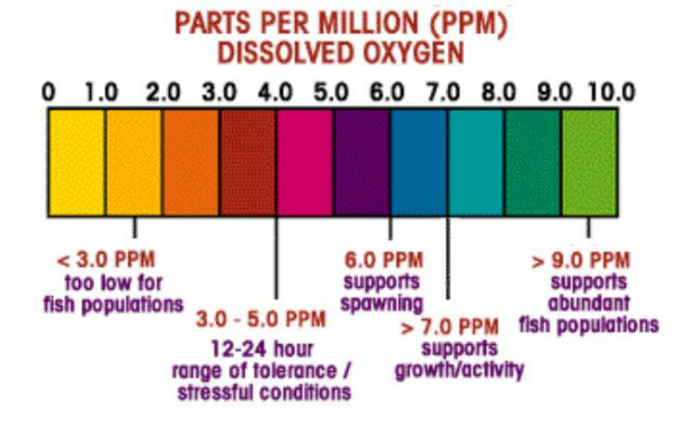
Figure 1. Oxygen requirements for fish.

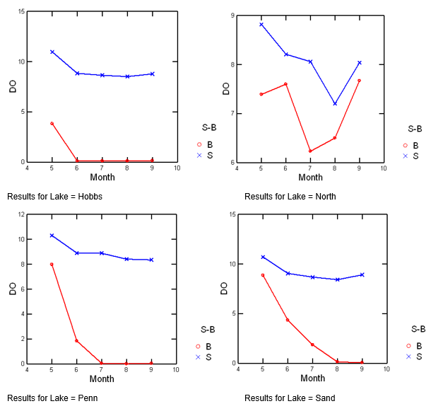
Figure 2. Dissolved Oxygen concentrations for surface and bottom waters in Little Pennesseewassee (Hobbs) and North Pond, and Pennesseewassee and Sand Pond through the 2021 season.

Figure 3 shows the Total Phosphorus concentrations at the surface and bottom of each lake over the 2021 season. The concentrations in the bottom waters generally increase over the summer, indicating a transport of phosphorus contained in organic matter from the surface to the bottom waters by dead algae and other organic matter. It may also be introduced through runoff and groundwater discharge into a lake. As mentioned earlier, the concentrations may also increase near the bottom due to low oxygen levels, which aids in the release of phosphorus from the sediments, called internal loading. Note also that the values for Hobbs Pond and North Pond get over twice as high as the other two lakes. It also is interesting that the bottom P concentrations have a steady increasing trend during the season, but in Sand Pond, there was an initial high and then a dip in concentrations until September.

Scientists have developed a rough idea of what levels of phosphorus in lakes can lead to problems (Table2). The phosphorus content of the surface water of our lakes, except North Pond, fall into the oligotrophic category, which is pretty good. North Pond ranks as mesotrophic, which is However, the bottom waters of North Pond and Hobbs Pond are in the eutrophic category. Eutrophic means over-enriched with nutrients, and susceptible to algal blooms and other problems.

Table 2 Table of threshold values used to classify lakes. Note µ/L = ppb. (Source: https://www.encyclopedie-environnement.org/en/water/phosphorus-and-eutrophication/)
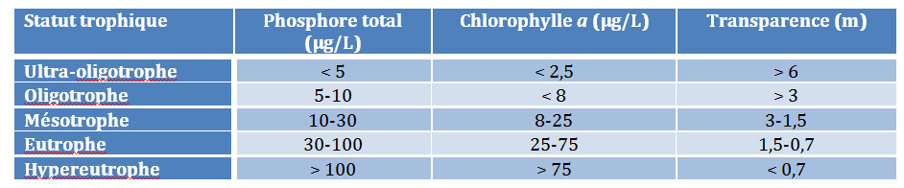

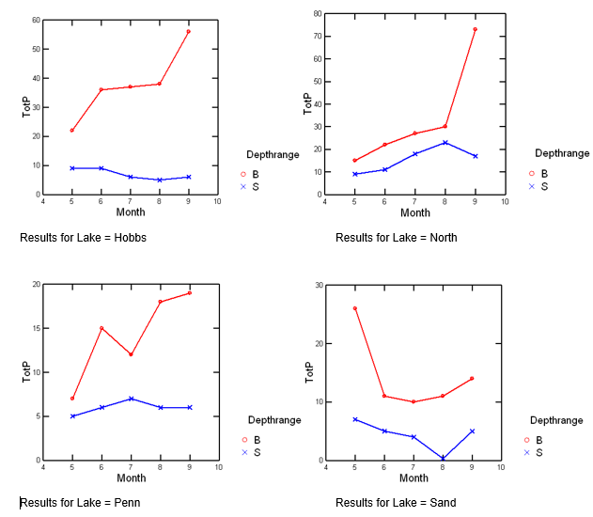
Figure 3. Total phosphorus concentration in the surface (S) and bottom (B) water for the four lakes during the 2021 season.
Secchi depth, shown in Figure 4, is a measure of water clarity. Clarity is impacted by dissolved and particulate matter. In our lakes it is mostly a function of particulate matter, namely algae. Secchi depth is not a very good measure for North Pond, since it is shallow and we always see all the way to the bottom. In the other three lakes, the Secchi depth is a good measure of clarity. What we see is that transparency of the water starts low and tends to increase as the summer progresses. This change is partially due to a spring “bloom” when phytoplankton become abundant followed by heating of the surface due to increased sunlight. The heating causes a layering of the water and allows the depletion of nutrients from the surface. A succession of different algal species from spring to summer and fall occurs due to their different abilities to compete for the remaining nutrients in the surface, and the sinking out of larger species.

The Secchi depths shown here are what are called “transparence” in Table 2. According to the table, this measure shows our lakes may be considered oligotrophic. Similarly, Table 2 ranges for chlorophyll also indicate our lakes should be considered oligotrophic, with the exception of North Pond, which would be mesotrophic (Figure 5). However, remember that the bottom waters are the potential problem as a phosphorus source that could change surface conditions.

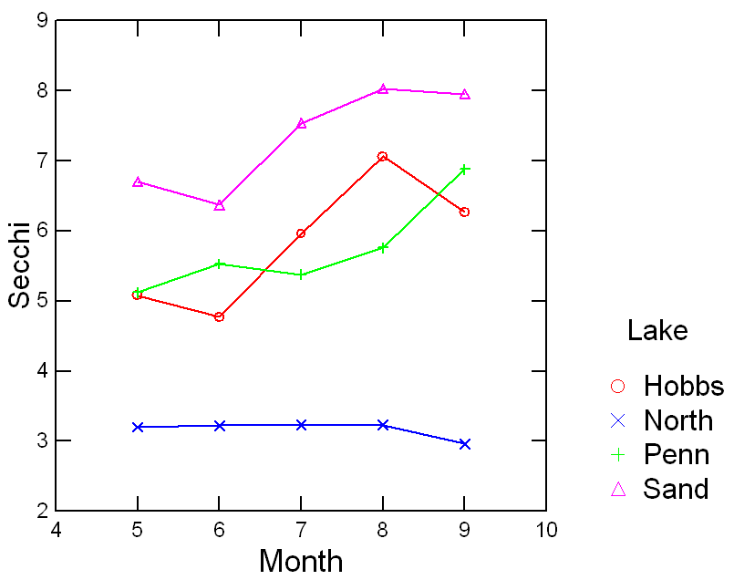
Figure 4. Secchi depths through the 2021 season for the four lakes.
Chlorophyll is an important parameter in that it measures the quantity of microscopic algae in the water. A small amount keeps our aquatic ecosystems healthy. But too much is a problem for the entire ecosystem, including humans. In Maine waters the average chlorophyll concentration is .0054 mg/L (https://www.mainevlmp.org/distribution-of-water-quality-data/ ). Our lakes are lower, with the exception of North Pond. The data in Figure 5 shows a relatively flat line for the chlorophyll concentrations in all lakes except North Pond. In North Pond the numbers increase dramatically in June, and then an unsteady decline. The relatively high chlorophyll in North Pond could be due to the higher phosphorous concentrations (10-20 ppb), similar to the deep layers of the other Sand and Pennessseewassee (see Figure 7).

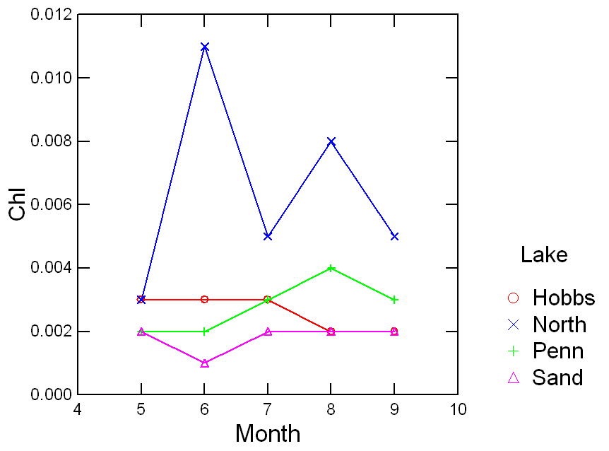
Figure 5. Chlorophyll values for the four lakes during the 2021 season.

Other parameters from the 2020 season

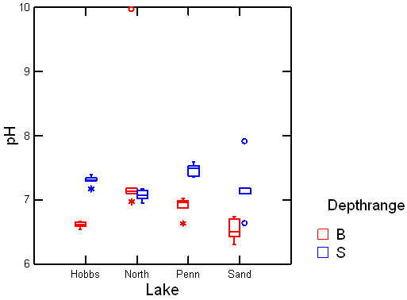
Figure 6. Box plot of pH values in surface and bottom waters of the lakes during the 2021 season. Horizontal line in the box is median, whiskers are the range, circles and asterisks are outliers.
The pH of a water body is a measure of its hydrogen ion concentration, which we commonly refer to as acidity. A pH of 1 is very acidic, and 14 is very basic, with neutrality at pH 7. Most surface waters tend to be in the 6-8 pH range, and our lakes are no exception. Figure 6 shows that average pH values this year ranged between 6.3 and 9.8, the latter value marked as an outlier on the graph (it is highly questionable that this was real given all the past data). The surface values tend to be slightly alkaline (or basic), while the bottom waters are slightly acidic. This is related to the phytoplankton algae. As they photosynthesize, they take in carbon dioxide, which in turn causes a reduction of hydrogen ions through associated chemistry. When they die and sink, the decompose in in the bottom waters which releases carbon dioxide, and that in turn results in the release of hydrogen ions. Carbon dioxide (or CO₂) can combine with water molecules and in the process releases hydrogen ions, which increases the acidity.
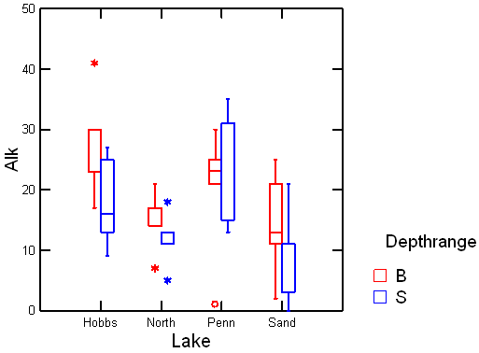
Figure 7. Box plot of Alkalinity in the surface and bottom waters of the lakes during the 2020 season. Horizontal line in the box is median, whiskers are the range, circles and asterisks are outliers.
Alkalinity is not a measure how alkaline the water is, but rather of its acid neutralizing capacity. High alkalinity can buffer water against pH changes. According to the Lake Stewards of Maine website the range of alkalinity in Maine waters is 11.9 on average, with a maximum of 156 (https://www.mainevlmp.org/distribution-of-water-quality-data/ ). Our lakes are just above the mean of other lakes in the region (Figure 7). The University of Massachusetts published the table below (Table 2) showing a lake’s sensitivity to acid rain. Those with lower alkalinities are more sensitive to acid rain than those with higher alkalinities. You can see that our lakes are mostly in the sensitive to non-sensitive to non-sensitive range, the exception being the surface waters of San Pond which had values from 0 to 21, but tending to the lower end of the scale.

Table 3. Alkalinity values associated with various levels of sensitivity to acidification by acid rain.
0* mg/l: Acidified | 5-10 mg/l: Highly Sensitive
0-2 mg/l: Critical | 10-20 mg/l: Sensitive
2-5 mg/l: Endangered | 20 mg/l: Not Sensitive

https://www.umass.edu/mwwp/protocols/lakes/ph_alkalinity_lake.html

Conductivity is a measure of the amount of ions in the water, more ions means greater conductivity. This seemingly odd parameter is useful because it can indicate pollution. One ion is of particular interest to us, and that is chloride. Chloride is the negative ion that pairs with the positive sodium ion in road salt (sodium chloride). So high conductivity measurements indicate a potential influx of road salt to the lakes during winter road operations. Typical freshwater streams are in the range of 100-2000 µS/cm, but most Maine lakes fall below 100, with an average of 50. The data for 2021 were very similar to last year’s values. North and Sand Ponds average 54 and 46 respectively (Figure 8). However, North Pond had a value of zero on one date which was probably an instrumentation error. Little Pennesseewassee and Lake Pennesseewassee are the highest with averages of 120 and 78.2, respectively. Both are adjacent to the highway, and more subject to road salt, which is a major contributor to conductivity in the Northeastern states. These values are also at the high end of the values found in Maine (https://www.mainevlmp.org/distribution-of-water-quality-data/ ).

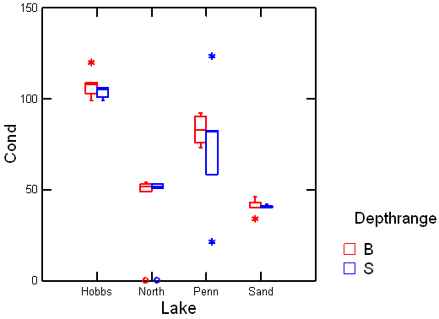
Figure 8. Box plot of conductivity values in the surface and bottom waters for the 2020 season. Horizontal line in the box is median, whiskers are the range, circles and asterisks are outliers.
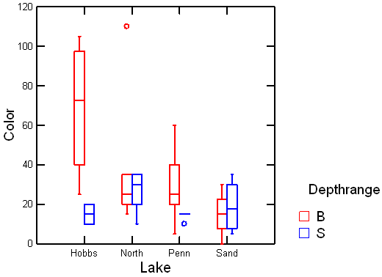
Figure 9. Box plot of Color of water (Platinum Units) for the lakes throughout the summer season. Horizontal line in the box is median, whiskers are the range, circles and asterisks are outliers.
Color of water can vary due to a number of reasons like suspended sediments, dissolved chemicals, certain species of phytoplankton or pollutants. Most often in typical lakes and streams, color is due to decomposing vegetation which releases organic compounds like a tea bag in a cup of water. The decomposition forms a number of chemical compounds collectively known as tannins or humic substances which have a coloration similar to tea. Since light is important for the growth of aquatic plants and phytoplankton, highly colored water may hamper their growth. In 2020, Little Pennesseewassee and North Pond both reached fairly high levels, around 90 color units, probably associated with significant amounts of rainfall during the first half of July. During the 2021 season only the bottom of Little Pennnesseewassee experienced values this high, the rest being mostly below 40 color units (Figure 9).

Individual Lake Analyses

Sand Pond:

Sand Pond is the best of the four lakes in terms of water quality. The surface phosphorus concentrations (Figure 3), and phytoplankton chlorophyll (Figure 5) were lower than in the other lakes (Table 1). As a result, water clarity was also greater (Figure 4). During 2021, San Pond had a stronger and deeper thermocline (the temperature transition between the warm surface water and the colder deeper waters) than we saw in 2020 (Figure 10). This is possibly due to fewer cloudy days during 2021, allowing the water to absorb more heat. The lake exhibits oxygen depletion in the deep waters (Figure 11), but the oxygen bump below the thermocline was not as large as last year. Indication less photosynthesis. The peak in oxygen concentrations just below the 5 meters, is a recurring feature of the lake caused by phytoplankton growing at depth. The thermocline is a barrier to diffusion of substances like phosphorus and other nutrients moving from the bottom to the surface. Phytoplankton here have found a balance between high nutrients (phosphorus) in the deeper waters while still being shallow enough to get enough sunlight for photosynthesis due to the water clarity of the surface layer. The Secchi depth shown in Figure 4 ranges between 6.5 and 8 meters, thus the transparency is the clearest of all four lakes.

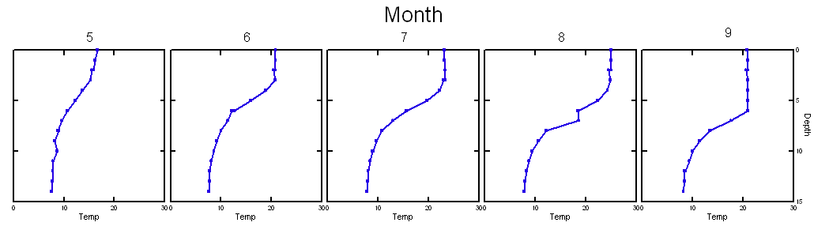
Figure 10. Sand Pond temperature profiles during the 2021 season.
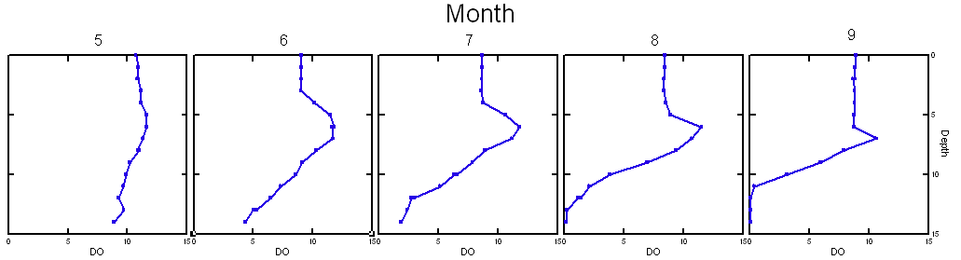
Figure 11. Sand Pond dissolved oxygen profiles during the 2021 season.
Due to the oxygen depletion in the deep-water phosphorus is released from the sediments. Phosphorus levels in the surface (4.3 parts per billion, ppb) waters increased a small amount over historical values, while the deep (14.4 ppb) decreased from historic values. We need to manage phosphorus in the watersheds of all these lakes. While Sand Pond remains good, we still need to watch the phosphorus content given the increase in the surface concentrations.

The pH values were normal (Fig 6), but the alkalinity was lower than the other lakes (Fig 7), indicating a potential for acidification. The conductivity values were the lowest of the four lakes (Figure 8). These low values indicate that runoff of road salt is not a problem, not surprising given the remoteness from the highways in the area. While some color was found in the water indicating decomposing leaves, the values were low (Figure 9).

Little Pennesseewassee (Hobbs Pond):
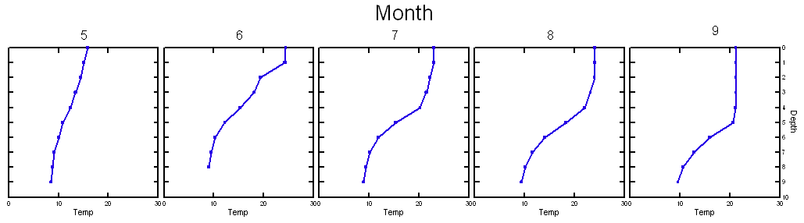
Figure 12. Temperature profiles for Little Pennesseewassee during the 2020 season.
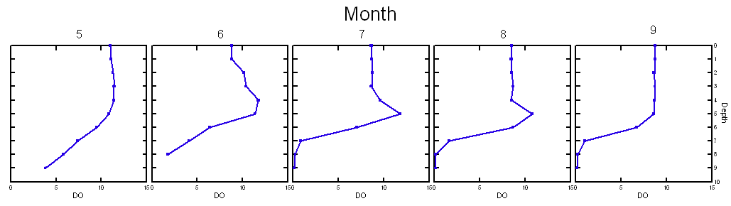
Figure 13. Dissolved oxygen profiles in Little Pennesseewassee for the 2020 season.

Little Pennesseewassee (Hobbs Pond), was affected in 2021 by a cyanobacterial bloom (bluegreen algae). The genus was identified as Planktothrix by the Maine Department of Environmental Protection. The temperature profiles showed a deeper thermocline (the transition between warmer surface and colder deep waters) in July and August than last year (Fig 12). This could have been due to wind mixing causing phosphorus to be brought into the surface water and subsequently stimulating the cyanobacterial bloom. The lake did not, however, experience unusually strong winds in July and August (Appendix A). Another possibility has been raised in that a beaver dam was removed releasing the ponded water behind it into Hobbs Pond

Hobbs Pond started to see increased bottom phosphorus concentrations in as early as June, remaining between 30-40 until September, when the concentration increased to over 55 ppb (Figure 3). Alarming is the fact that the value of 56 ppb recorded in September was the highest since data has been collected for the lake starting in 1976.

The dissolved oxygen concentrations in Little Pennesseewassee (Figure 13) were similar to the other deep lakes. The surface layer was well oxygenated, but at the bottom, oxygen levels fell to zero due to decomposition of organic matter as early as June. Like Sand Pond, the water here also had a “deep chlorophyll maximum” as indicated by the peak of oxygen just below the surface mixed layer at about 5 meters. These phytoplankton are taking advantage of the higher nutrient levels in the deep layer, while still getting enough sunlight for photosynthesis, which causes the oxygen peak. However, the oxygen peak was not as pronounced as in the previous year, similar to Sand Pond.

Water clarity, as indicated by Secchi depth (Figure 4), was lowest in June, but then increased in July and August and declined slightly in September, a pattern very similar to last year. This is due to phytoplankton growth, which was high initially, as indicated by the Chlorophyll concentration (Figure 5), and then declined in August due to nutrient depletion in the surface water (Figure 6).

The pH values were normal (Fig 6), and the alkalinity was similar to other lakes ranging between 10 and 30 (Fig 7). The alkalinity values of the lake were above the state average, which gives it some protection from acidification. Conductivity was the highest of any of the lakes, and exceeded the higher end normal for Maine lakes (Figure 8). This is due to runoff of winter salt from the highway. Color values for the surface were similar to the other lakes, but the bottom water had levels 2-3 times those of other lakes (Figure 9). The color of water in the region is mostly due to decomposing leaves.

Lake Pennesseewassee:

Lake Pennesseewassee is also a medium productive lake (mesotrophic) having moderate amounts of phosphorus and phytoplankton in the surface waters. Water clarity is on the order of 5.7 meters (Table 1) during the summer, which is also indicative of a mesotrophic lake. Like the other deep lakes in our area, oxygen depletion occurs in the bottom waters (Figure 2), and there is elevated phosphorus in the bottom waters (Figure 3) due to release from the sediments during times of low oxygen. This is a warning sign that phosphorus needs to be managed, or the lake could suffer phytoplankton blooms as has happened in other areas.

The temperature profile in May is just starting to show signs of stratification as the surface is being warmed by the sun (Figure 14). The stratification becomes stronger (larger difference between surface and deep-water temperatures) through the season, and the surface layer becomes thicker, deepening the thermocline.
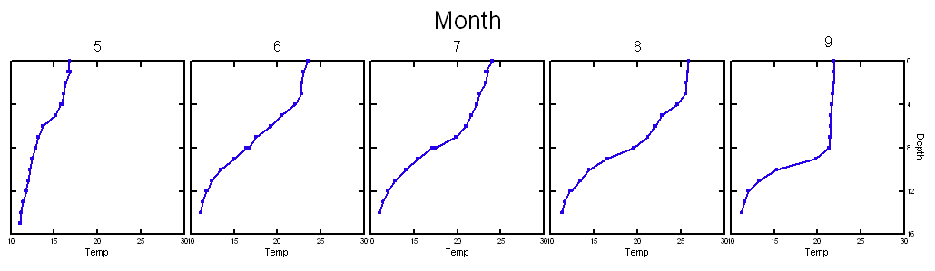
Figure 14. Temperature profiles in Lake Pennesseewassee (Norway Lake) during the 2020 season.
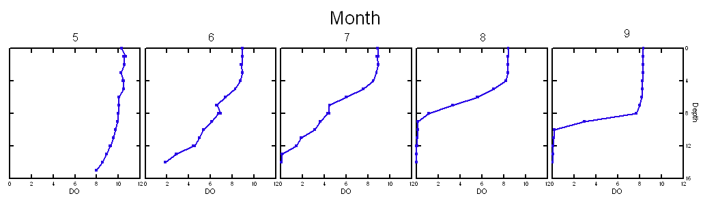
Figure 15. Dissolved oxygen profiles in Lake Penesseewassee (Norway Lake) during the 2020 season. May data was not taken.
As early as May, we see slightly lower oxygen concentrations near the bottom (Figure 15). The oxygen concentration in the bottom waters continue to decrease throughout the summer due to decomposition of organic matter and no mechanism to replenish oxygen in the deep water. By August the deep water is devoid of oxygen from the bottom to almost 6 meters from the surface, and the difference between surface and deep water becomes very sharp in September as the thermocline is deepened due to stronger winds (Appendix A).

The Secchi depth increases meaning the water is becoming clearer throughout the summer (Figure 4). Interestingly chlorophyll seems to increase slightly during the summer (Figure 5). These trends seem to contradict each other, but the explanation may lie in changing species composition of the phytoplankton. Phosphorus concentrations in the surface remain relatively constant, but are seen to increase in the bottom water to about 29 ppb (Figure 3). indicating a release of phosphorus stored in the lake sediments caused by the low oxygen environment in the deeper waters (Figure 15).

The pH values were in the normal range for surface waters, around 7.5 in the surface and just below 7 in the deep water (Figure 6). Alkalinity values were also normal for our area, but higher than the state average, indicating the system is well buffered against pH changes (Figure 7). Conductivity values (Figure 8) were second only to Little Pennesseewassee (Hobbs Pond). While both of these lakes are located next to State Route 118, Pennesseewassee has a lower conductivity because there is more volume to dilute the road salt than in Hobbs Pond. The conductivity levels, while relatively high are below the maximum levels found in Maine. Water color was higher in the bottom water than in the surface indicating more leaf decomposition affecting the deeper water.

North Pond:
North Pond is relatively shallow (3 m) in comparison to the other lakes. For that reason, it mixes quite easily from top to bottom with any wind. This means that it does not really form two layers for any length of time. During 2021 we did observe weak temperature stratification from May through August (Figure 16). Unlike the other lakes which suffer from oxygen depletion in the bottom waters, North Pond typically has plenty of oxygen throughout the water column as a result of wind mixing. However, in 2021 the stratification allowed the near bottom water to become low in oxygen (hypoxic), although the levels never became less than 6 mg/L (Figure 17), which is sufficient to allow fish spawning (Figure 1).
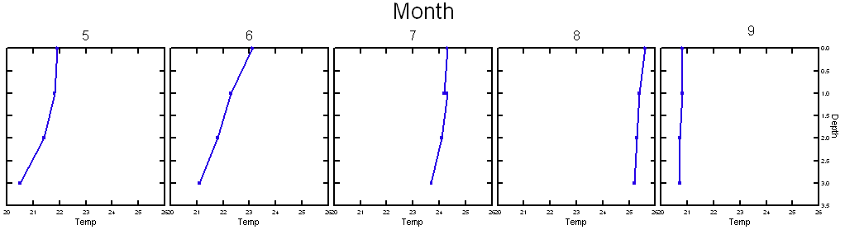
Figure 16. Temperature profiles for North Pond during the 2020 season.
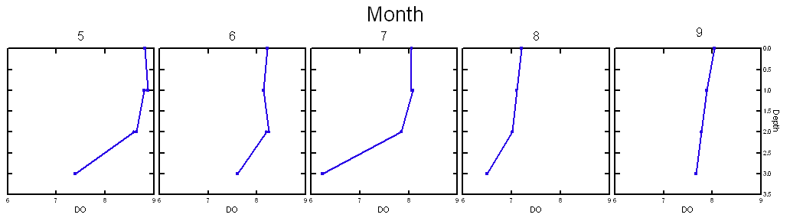
Figure 17. Dissolved oxygen profiles for North Pond during the 2020 season.

Phosphorus concentrations increased in both the surface and bottom waters through the summer to levels of 20-30 ppb (Figure 3). The surface values dropped slightly in September, but the bottom water reached a very high maximum of 74 ppb. This maybe from internal loading, as the bottom consists of very thick layers of peat. These high concentrations do not seem to cause nuisance phytoplankton blooms in the Pond itself. However, North Pond is a water source for Pennesseewassee, so could contribute to the phosphorus concentrations in that lake.
The chlorophyll levels are indicative that this lake is moderately productive (mesotrophic). As stated above, phytoplankton blooms do not seem to be a problem. However, the average chlorophyll concentrations are the highest of the four lakes (Figure 5). A good sign is that the current chlorophyll concentrations have not risen above average historical values (Tale 1).

North Pond pH values are just above 7, which is normal for lakes. Alkalinity values were just above average values for Maine. Since alkalinity represents the buffering capacity of the water and the pH is near 7, it could be somewhat susceptible to acidification. Conductivity is just about at the State average, reflecting normal geologic conditions and low input of road salt. The color of the water is similar to that of the other lakes.

Methods

The methods described here are the ones currently employed. In the historical records discussed in this Report, other methods may have been used.

Water Clarity:
Water transparency was measured with a standard Secchi disk, 20 cm in diameter, with black and white quadrants. It was lowered on a measuring tape marked in meters. A measurement was made to the nearest centimeter, while looking through an Aquascope II©, at the point where the disk disappeared.

Water Samples:
Water samples were collected in 2-liter polycarbonate bottles. The first was immersed inverted at the surface and filled by turning it right-side up. A second was filled with from a van Dorn water bottle (marketed as a Beta bottle). The van Dorn bottle can be lowered to a specific depth with a marked line, and then closed at depth by sending a weight, called a messenger, down the line. The weight triggers the closing of the ends of the sampler. A second 2 liter polycarbonate bottle was filled from the van Dorn sampler. The 2-liter bottles were covered to seal out light with aluminum foil and duct tape. They were kept in a cooler on ice until return to shore for sample processing.

One exception to this was the collection of total phosphorus samples. For surface samples, a conical tube was inverted and passed through the surface in an arc so that the tube emerged right-side up. The deep samples for total phosphorus were collected in a conical tube directly from the van Dorn sampler prior to any other sample being taken.

Total Phosphorus:
Total phosphorus samples were collected as described in Water Samples. Both samples were collected in 50 ml tubes to measure out the volume, and then transferred into Erlenmeyer flasks and sealed with a screw top. These samples were kept refrigerated and sent to the Maine State Health and Environmental Testing Laboratory (HETL) in Augusta to be analyzed.

Chlorophyll:
Chlorophyll was sampled from the 2-liter bottles collected at the surface and at depth as described in Water Samples above. The water was then vacuum filtered with a hand pump (Mightyvac™) through a 0.45 micrometer pore-size filter. The volume filtered was recorded, and typically was between 300-600 mL. After filtration was complete, the filters were frozen and sent to the Maine State Health and Environmental Testing Laboratory (HETL) in Augusta to be analyzed spectrophotometrically.

Dissolved Oxygen:
DO was measured at 1-meter intervals from surface to the bottom with a YSI ProODO meter. The meter was calibrated daily with air-saturated water. This was done by filling a container with tap water and bubbling air through it with the use of an aquarium pump and air stone. Barometric pressure was obtained for the calibration from the National Weather Service, using the Lewiston-Auburn station. The meter has a stated accuracy ± 0.1 mg/L for DO and ± 0.2°C for temperature.

Temperature:
Temperature was measured at 1-meter intervals from surface to the bottom with a YSI ProODO meter. The meter has a stated accuracy of ± 0.2°C for temperature.

Conductivity:
Conductivity was sampled from the 2-liter bottles collected at the surface and at depth as described in Water Samples above. The conductivity was then measured on a subsample of about 100 ml, with an Orion VersaStar meter and an Orion 013005MD conductivity cell. The probe was calibrated with a 84 microSiemens standard solution. The stated accuracy of the instrument is ± 0.5% of reading, ±1 digit.

pH:
The pH was sampled from the 2-liter bottles collected at the surface and at depth as described in Water Samples above. The pH was then measured with an Orion VersaStar meter and an Orion 8302BNUMD Ross Ultra pH/ATC triode. The probe was calibrated each sampling day with a pH 7.0 and pH 4.0 buffer solutions. The meter has a stated accuracy of ± 0.002 pH units.

Alkalinity
Alkalinity was measured with a Hannah HI775 Freshwater Alkalinity Checker. It is a photometric instrument that uses an LED and silicon photocell. The stated accuracy is ±5 mg/L.
The results for alkalinity measurements were compared with results obtained by the HETL laboratory. They were done with EPA approved methods. Our results are comparable to the HETL results.

Color:
Water color was measured with a Hannah HI727 Color Checker. It is a photometric instrument that uses an LED and silicon photocell. The stated accuracy is ±10 Platinum Color Units.

Appendix A.
Weather data from KLEW Auburn/Lewiston, https://weatherspark.com/h/m/147317/2021/5/Historical-Weather-in-May-2021-at-Auburn-Lewiston-Municipal-Airport-Maine-United-States

