The water quality analysis in 2016 made a concerted effort to distinguish conditions in the surface layer(epilimnion) from those in the bottom layer (hypolimnion) where they existed. The analysis revealed that conditions were similar to what they had been historically for Secchi depth, Total Phosphorus, and Chlorophyll. The average values measured during 2016 are close to the average values of 40+ years of historic data. One exception was Total Phosphorus in Hobbs Ponds where last year’s average was 11 µg/L in comparison to the historic values of 6.7 µg/L. A second exception was the chlorophyll average of North Pond was 7.66 mg/L while the historical average was 2.8 mg/L.
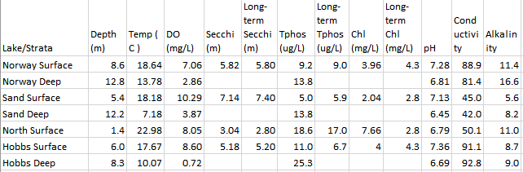
While comparisons are often made to long term averages, we are starting to look at recent trends since averages of many years can sometimes hide what is currently happening. For example, the range of phosphorus levels in North Pond over the past 30 years is relatively high, ranging between 10 and 30 ppb. It is important to note that values above 25 ppb have only been recorded in the last decade. This would indicate that these spikes are of recent origin, possibly related to an increase in extreme weather events, which have likely exacerbated existing soil erosion problems, and have the potential to cause new problems associated with our developed watersheds. Our data indicates that our attention to watershed erosion is very much needed to help prevent further water quality deterioration. We will expand trend analysis in the future.
We also measured other parameters in the lakes including dissolved oxygen (DO), pH, conductivity and alkalinity. Things to note about DO are that the deep water in all the lakes has much lower oxygen content than the surface water, an indication that organic matter being produced in the surface is sinking and decomposing in the deep layer. Hobbs Pond has the worst oxygen depletion in the deep layer. The measured pH values also show that decomposition is occurring in the deep water, given the lower pH values. Conductivity is often an indicator of road salt entering a lake, and this seems to be the case here, with higher conductivity values for Norway and Hobbs, and the lowest values in Sand Pond. Alkalinity can be interpreted as the ability to neutralize acids (buffering capacity). For this Sand Pond has the lowest values, and Norway and North Pond have the highest values.

